CSE 219 — Signals and Linear Systems
Lec 0–2 · DTFT and DFT, DFT Properties and Circular Convolution
Lesson notes · Exam approach · TF practice with solutions · Quick notes (Ashraf Sir's portion)

How to Read These Notes
EXAM FOCUS | Exam importance, where it appears in the TF collection
MEMORIZE | Rules, tables and formulas to memorize
TRAP | Common mistakes and exam traps
EXAM-READY ANSWER | Model wording you can write in the exam
NOTE | Extra explanation / clarification
Grey box, monospace | Code, worked tables, derivations and hand-drawn sketches
Centered grey box | Formula to remember / final numerical result
Purple heading / ✔ green | Practice questions / their solutions

Contents
Exam Map — What the TF Papers Ask — DFT questions and how much they matter
Lesson 1 — From Fourier Series to the DFS and DFT — sampling a periodic signal, N unique coefficients, the DFT pair
Lesson 2 — The DTFT, and the DFT as Its Samples — 2π-periodic spectrum, inverse DTFT, zero-padding, bins → Hz
Lesson 3 — DFT Properties — the clock (mod N), circular shift, modulation, symmetry, Parseval
Lesson 4 — Circular Convolution and Filtering with the DFT — multiply DFTs = circular convolution; zero-pad to L + M − 1
Quick Notes — DTFT and DFT — merged revision notes + key diagrams
NOTE Slide numbers are PDF page numbers of Lecture 1 - DTFT and DFT.pdf (38 pages, “Lec 1”) and Lecture 2 - DFT Properties and Applications.pdf (26 pages, “Lec 2”); the printed slide number on each page is one less. Lecture 0 (Overview of the Transforms, 41 pages) is history and says “Nothing here is examinable”; its one useful picture — the four-transform square — is in Lesson 1.

Exam Map — What the TF Papers Ask
Session (paper) | Questions answered by this note
2023-24 (CSE 219) | Q5(b) Linear convolution of {1,2} and {1,1} using the DFT (10)
2016-17 (CSE 311) | Q3(a) Derive the DFT from G(f); f₀ = 1/T₀; compute a DFT; choosing T_s and T₀ (20)

EXAM FOCUS Only two TF questions come straight from these decks (CSE 219 2023-24 Q5(b): linear convolution through the DFT, 10 marks; CSE 311 2016-17 Q3(a): derive and compute a DFT, 20 marks). But every FFT, Bluestein and sampling question (Lessons 5–12) is built on the DFT pair, W_N, the bin reading and circular convolution. Learn: the DFT/IDFT pair by heart, the 4-point W₄ table, X[N − k] = X*[k], and the zero-padding rule N ≥ L + M − 1.

Lesson 1 — From Fourier Series to the DFS and DFT
Lec 0 sl. 22; Lec 1 sl. 2–19

1. Four Fourier Transforms, One Rule (Lec 0 sl. 22; Lec 1 sl. 2)
 | continuous time | discrete time
periodic | CTFS: discrete, aperiodic spectrum a_k | DFS/DFT: discrete, periodic spectrum X[k]
aperiodic | CTFT: continuous, aperiodic X(jω) | DTFT: continuous, periodic X(e^{jω})

MEMORIZE Discrete in one domain ⇔ periodic in the other. Sampling time makes the spectrum periodic; keeping only N frequency bins makes time N-periodic. The DFT is the only one a computer can compute.

2. Sampling a Periodic Signal (sl. 5–10)
x(t) has period T₀; take N samples per period, T₀ = NT_s, x[n] = x(nT_s) (N-periodic). Represent the sampling as x_p(t) = x(t)p(t) = Σ x[n]δ(t − nT_s). Its CTFS coefficients: the impulses sift the integral into a finite sum.
c_k = (1/T₀)∫_{T₀} x_p(t)e^{−jkω₀t}dt = (1/T₀)Σ_{n=0}^{N−1} x[n]e^{−jkω₀nT_s}, ω₀T_s = 2π/N
= (1/T₀)Σ_{n=0}^{N−1} x[n]e^{−j2πkn/N}
c_{k+N} = c_k·e^{−j2πn} = c_k ⇒ only N distinct coefficients (sampling in time made the spectrum periodic)
c_{−k} = c_{N−k} ⇒ negative frequencies fold onto the upper bins

3. The Inverse by Orthogonality (sl. 12–14)
Σ_{k=0}^{N−1} e^{j2πk(n−m)/N} = N if n = m, 0 if n ≠ m (geometric series: (1 − e^{j2π(n−m)})/(1 − e^{j2π(n−m)/N}) = 0)
⇒ x[n] = (1/N)Σ_k (T₀c_k)e^{j2πkn/N}

4. DFS and DFT (sl. 15–19)
DFS: a_k = (1/N)Σ_{n=0}^{N−1} x̃[n]e^{−j2πkn/N}, x̃[n] = Σ_{k=0}^{N−1} a_k e^{j2πkn/N}
DFT: X[k] = Σ_{n=0}^{N−1} x[n]W_N^{kn}, x[n] = (1/N)Σ_{k=0}^{N−1} X[k]W_N^{−kn}, W_N = e^{−j2π/N}
Bridges: X[k] = N·a_k (DFT = DFS rescaled); c_k = X[k]/T₀ (CTFS of the sampled periodic signal). The DFT never needs the continuous signal: any list of N numbers has one (sl. 18). Reading the bins: k = 0 … N/2 are positive frequencies (low → high); k = N/2 … N − 1 are the folded negative frequencies (high → low).
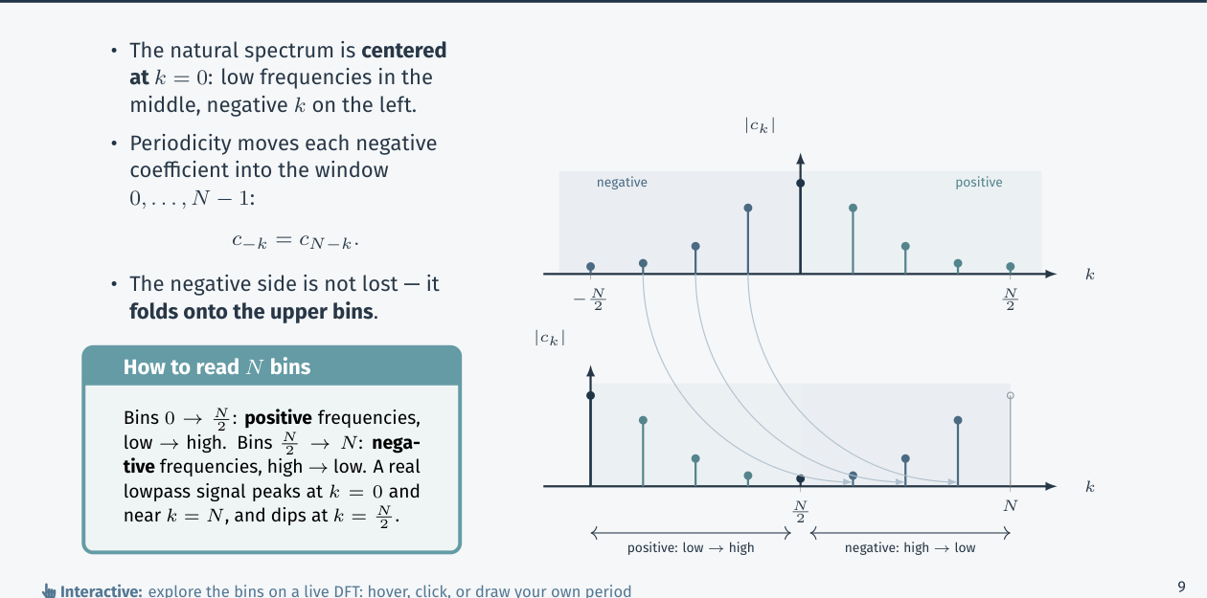
Figure 1.1 — Negative-frequency coefficients fold onto the upper bins (Lec 1, sl. 11)

Exam Approach
1. Derivation: sample, write x_p as an impulse train, sift the CTFS integral, use ω₀T_s = 2π/N.
2. Prove N-periodicity of the coefficients (k → k + N).
3. Inverse: multiply by e^{j2πkn/N}, sum over k, use the orthogonality sum.
4. State the bin ↔ frequency map.

Practice — Lesson 1
(a) Actual — CSE 311 2016-17 Q3(a). (b) Constructed (Lec 1, last slide).
(a) g(t) is sampled over 0 ≤ t ≤ T₀ at intervals T_s giving N₀ samples; G_q = Σ_{k=0}^{N₀−1} g_k e^{−jqΩ₀k}, g_k = T_s g(kT_s), G_q = G(qf₀), Ω₀ = 2πf₀T_s. (i) Derive this from G(f). (ii) Prove f₀ = 1/T₀. (iii) Compute the DFT for g(0..3) = 1, 2, 3, 4 (t = 0, 1, 2, 3); give the sample frequencies and G(f). (iv) How should T_s and T₀ be chosen? (4 + 5 + 5 + 6)
(b) Compute the 4-point DFT of {1, 0, −1, 0}. Which bins light up and why?

✔ Solution
(i) G(f) = ∫₀^{T₀} g(t)e^{−j2πft}dt ≈ Σ_{k=0}^{N₀−1} g(kT_s)e^{−j2πfkT_s}·T_s (rectangle rule, time-limited g)
evaluate at f = qf₀: G(qf₀) = Σ g_k e^{−j2πqf₀kT_s} = Σ g_k e^{−jqΩ₀k}, Ω₀ = 2πf₀T_s
(ii) Sampling in time makes G_q periodic; requiring the N₀ frequency samples to cover exactly one period
(G_{q+N₀} = G_q) needs e^{−jN₀Ω₀k} = 1 for all k ⇒ N₀Ω₀ = 2π ⇒ 2πf₀T_sN₀ = 2π ⇒ f₀ = 1/(N₀T_s) = 1/T₀
(iii) T_s = 1, N₀ = 4 ⇒ T₀ = 4 s, f₀ = 0.25 Hz, Ω₀ = π/2, W = e^{−jπ/2} = −j
G₀ = 1+2+3+4 = 10 f = 0
G₁ = 1 − 2j − 3 + 4j = −2+2j f = 0.25 Hz
G₂ = 1 − 2 + 3 − 4 = −2 f = 0.5 Hz (= f_s/2)
G₃ = 1 + 2j − 3 − 4j = −2−2j f = 0.75 Hz ≡ −0.25 Hz (G₃ = G₁*)
(iv) T_s ≤ 1/(2B) to avoid aliasing (B = essential bandwidth); T₀ long enough to capture g (time-limited) and
to give the needed resolution f₀ = 1/T₀; N₀ = T₀/T_s, preferably a power of 2 for the FFT (zero-pad g)

(b) X = {0, 2, 0, 2}: x = cos(πn/2) has frequency ω = π/2 = bin 1 and its negative partner −π/2 ≡ bin 3 (cos = ½e^{jπn/2} + ½e^{−jπn/2}, each with weight N/2 = 2).

Lesson 2 — The DTFT, and the DFT as Its Samples
Lec 1 sl. 20–34
Aperiodic finite sequence x[n] (0 ≤ n ≤ N − 1). CTFT of the impulse train x_p(t) = Σx[n]δ(t − nT_s): X_p(jω) = Σ x[n]e^{−jωnT_s}. Relabel ωT_s → ω (digital frequency, rad/sample):
X(e^{jω}) = Σ_n x[n]e^{−jωn} x[n] = (1/2π)∫_{2π} X(e^{jω})e^{jωn}dω
- 2π-periodic: X(e^{j(ω+2π)}) = X(e^{jω}) since e^{−j2πn} = 1 (sl. 25). Principal interval [−π, π] ↔ physical [−ω_s/2, ω_s/2].
- Inverse (sl. 26): substitute the analysis sum, swap sum and integral, use (1/2π)∫_{−π}^{π}e^{jωr}dω = δ[r].
- DFT = DTFT samples (sl. 29): X[k] = X(e^{jω})|_{ω=2πk/N}. Periodic view: FS coefficients; aperiodic view: N samples of the DTFT — the same N numbers.
- Zero-padding to M ≥ N (sl. 31): same DTFT, sampled at spacing 2π/M — more pixels, not more information.
- Bins to Hz (sl. 33–34): f_k = k f_s/N for 0 ≤ k ≤ N/2, (k − N)f_s/N above; Δf = f_s/N = 1/T₀ (numpy.fft.fftfreq order).
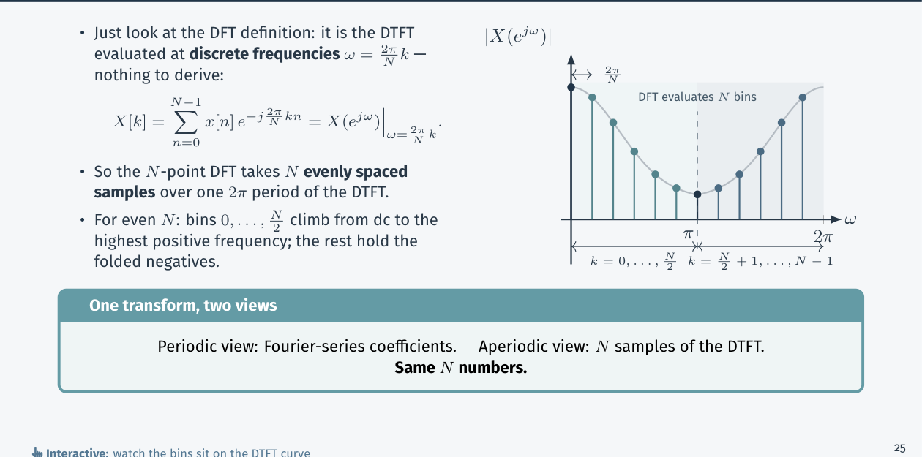
Figure 2.1 — The N-point DFT samples one period of the DTFT (Lec 1, sl. 29)
Worked example (sl. 32): x = {1, 2, 3, 4}, N = 4, W₄ = −j
W₄^{kn}: k=0: 1 1 1 1 | k=1: 1 −j −1 j | k=2: 1 −1 1 −1 | k=3: 1 j −1 −j
X = {10, −2+2j, −2, −2−2j}; |X| = {10, 2√2, 2, 2√2}; X[3] = X*[1] (bin 3 = bin 1's negative partner)
N = 8, f_s = 8 kHz: Δf = 1 kHz; bins 0..4 → 0..4 kHz, bins 5,6,7 → −3, −2, −1 kHz

Exam Approach
1. Write W_N and its powers (W₄ = −j, W₈ = (1 − j)/√2).
2. Tabulate W_N^{kn} (it is periodic in kn mod N).
3. Sum row by row; check X[0] = Σx and X[N − k] = X*[k] for real x.
4. Convert bins to Hz with f_s/N.

Lesson 3 — DFT Properties
Lec 2 sl. 2–12
Everything lives on a clock: indices are taken mod N, ((n))_N = n mod N, e.g. ((9))₈ = 1, ((−1))₈ = 7; the DFT sees the periodic extension x̃[n] = x[((n))_N]. One proof move gives every property: substitute into the DFT sum, re-index, and let the clock absorb whatever spills past the edge.
Property | Time | DFT
linearity | a x[n] + b y[n] (same N) | a X[k] + b Y[k]
circular time shift | x[((n − m))_N] | W_N^{km} X[k] (phase only)
modulation | W_N^{−k₀n} x[n] | X[((k − k₀))_N]; (−1)ⁿx ↔ X[k − N/2] (low ↔ high)
time reversal | x[((−n))_N] | X[((−k))_N]
conjugation | x*[n] | X*[((−k))_N]
real signal | x real | X[N − k] = X*[k]: |X| even, ∠X odd about N/2
duality | X[n] | N x[((−k))_N]
circular convolution | x ⊛ h | X[k]H[k]
multiplication | x[n]h[n] | (1/N) X ⊛ H
Parseval | Σ|x[n]|² | (1/N)Σ|X[k]|²

Circular shift proof: Σ x̃[n − m]W^{kn} = W^{km} Σ_{r=−m}^{N−1−m} x̃[r]W^{kr} = W^{km}X[k] (any N consecutive terms)
Parseval check on {1,2,3,4}: 1+4+9+16 = 30 = (100 + 8 + 4 + 8)/4 ✓; |X[k]|²/N = energy in bin k

TRAP • Shifts are circular: x[n − m] on N points wraps the tail to the front. • Linearity needs equal lengths — zero-pad the shorter sequence first. • Real and even x̃ ⇒ X real.

Lesson 4 — Circular Convolution and Filtering with the DFT
Lec 2 sl. 13–23
Linear convolution y = x * h has length L + M − 1. Multiply two N-point DFTs and invert:
y[n] = (1/N)Σ_k X[k]H[k]W^{−kn} = Σ_m x[m]·[(1/N)Σ_k H[k]W^{−k(n−m)}] = Σ_{m=0}^{N−1} x[m] h[((n − m))_N]

(x ⊛ h)[n] = Σ_{m=0}^{N−1} x[m] h[((n − m))_N] ⇔ X[k]H[k]
Two-wheel picture (sl. 16): x on the outer wheel, h reversed on the inner wheel; rotate one tick per output, multiply across the spokes, add. The off-edge taps of linear convolution (which multiply nothing) are instead wrapped onto x's tail — that wrap (time aliasing) is the only difference.
Example (sl. 21): x = {2,4,5,6,5,3,2,1}, h = {1,2,1}
linear (length 10): {2, 8, 15, 20, 22, 19, 13, 8, 4, 1}
circular N = 8: {6, 9, 15, 20, 22, 19, 13, 8} — y[0] = 2+4, y[1] = 8+1: the tail {4, 1} wrapped onto the front

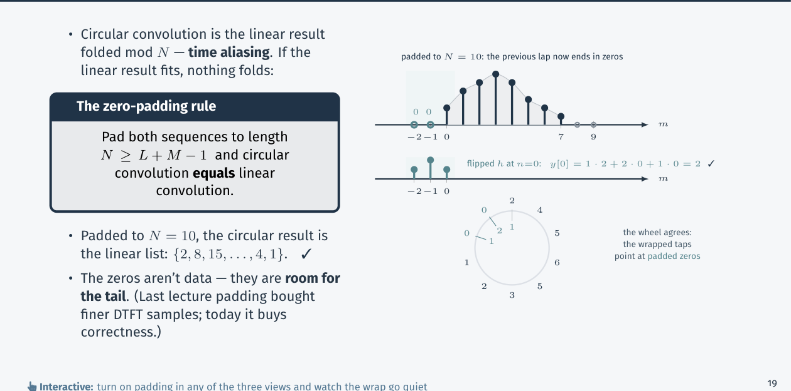
Figure 4.1 — Zero-padding to N = 10 parks the wrapped taps on zeros (Lec 2, sl. 22)
Circular = linear ⇔ N ≥ L + M − 1 (zero-pad both)
Filtering recipe (sl. 23): 1) N ≥ L + M − 1, pad x and h 2) X = DFT{x}, H = DFT{h}
3) Y = X·H bin by bin 4) y = IDFT{Y}; keep L + M − 1 samples
Cost with direct DFTs ~N² each (loses to L·M); with the FFT ~N log₂N (Lesson 8) — the fastest known way

Exam Approach
1. Pick N ≥ L + M − 1 (a power of 2 if an FFT is asked).
2. Zero-pad, compute both DFTs (W₄ table).
3. Multiply bin by bin.
4. IDFT: x[n] = (1/N)Σ X[k]W^{−kn}; check against the direct convolution.

Practice — Lesson 4
(a) Actual — CSE 219 2023-24 Q5(b). (b) Practice set 4.1, 4.4.
(a) x = {1, 2}, h = {1, 1}. Show step by step the linear convolution using the naive DFT method. (10)
(b) {1, 2} * {1, −1} with a 4-point DFT; {1, 0, 1} * {1, −1, 2} with a 4-point DFT (show the wrap).

✔ Solution
(a) L + M − 1 = 3 ⇒ use N = 4 (N = 3 also works). Pad: x = {1,2,0,0}, h = {1,1,0,0}; W₄ = −j
X[k] = Σ x[n](−j)^{kn}: X = {3, 1 − 2j, −1, 1 + 2j}
H[k]: H = {2, 1 − j, 0, 1 + j}
Y = XH = {6, (1−2j)(1−j) = −1 − 3j, 0, −1 + 3j}
y[n] = ¼Σ Y[k] j^{kn}:
y[0] = ¼(6 − 1 − 3j + 0 − 1 + 3j) = 1
y[1] = ¼(6 + (−1−3j)j + 0 + (−1+3j)(−j)) = ¼(6 + 3 − j + 3 + j) = 3
y[2] = ¼(6 − (−1−3j) + 0 − (−1+3j)) = ¼(6 + 1 + 3j + 1 − 3j) = 2
y[3] = ¼(6 + (−1−3j)(−j) + 0 + (−1+3j)(j)) = ¼(6 − 3 + j − 3 − j) = 0
y = {1, 3, 2} (+ a trailing 0) = direct x * h ✓

(b) {1,2}*{1,−1}: X = {3, 1−2j, −1, 1+2j}, H = {0, 1+j, 2, 1−j} ⇒ y = {1, 1, −2, 0}
{1,0,1}*{1,−1,2}: linear = {1, −1, 3, −1, 2} (N ≥ 5 ⇒ use 8); with N = 4 the last sample wraps:
circular = {1 + 2, −1, 3, −1} = {3, −1, 3, −1}

Quick Notes — DTFT and DFT
Revision points for Lessons 1–4.

L1 · DFS/DFT
- c_k = (1/T₀)Σx[n]e^{−j2πkn/N}; c_{k+N} = c_k; c_{−k} = c_{N−k}.
- X[k] = Σx[n]W^{kn}, x[n] = (1/N)ΣX[k]W^{−kn}, W_N = e^{−j2π/N}; X[k] = N a_k.

L2 · DTFT
- X(e^{jω}) = Σx[n]e^{−jωn}, 2π-periodic; inverse (1/2π)∫_{2π}.
- X[k] = X(e^{j2πk/N}); zero-padding = finer samples; f_k = k f_s/N.

L3 · Properties
- circular shift ↔ W^{km}X[k]; real x ⇒ X[N−k] = X*[k]; Parseval Σ|x|² = (1/N)Σ|X|².

L4 · Circular conv
- XH ↔ x ⊛ h; circular = linear iff N ≥ L + M − 1.
- {1,2} * {1,1} = {1,3,2} via 4-point DFTs: Y = {6, −1−3j, 0, −1+3j}.

Key Diagrams to Reproduce
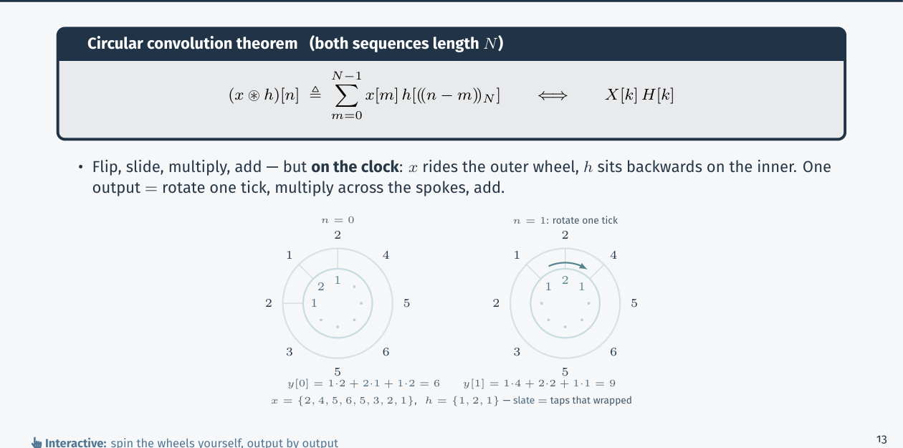
Circular convolution: two wheels (Lec 2, sl. 16)

